How to Change your Computer Windows Login Password
**If you have an aircard - You must be connected to the GlobalProtect VPN**

- Hold the ctrl+alt+del keys down

- Click on change password

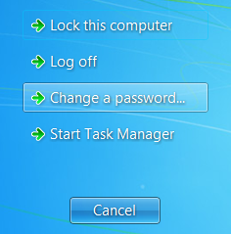

- Type your old password, your new password and then confirm and save. The new password must be 6 or more characters long, must include a combination of characters such as lower case, CAPITALS, and Numbers and cannot be anything that was used the previous 2 times.
