How to add a printer

- Open up the start menu

- In the search field type \\wc-cgy-print_sr and hit enter
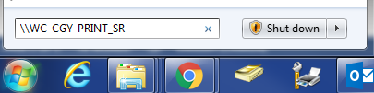

- Double click on the printer you’d like to add. For example: wc-cgy-2nd-floor-copier


- After this window has popped up, the driver has been installed and you can print as normal
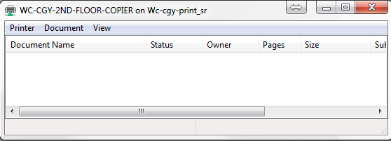

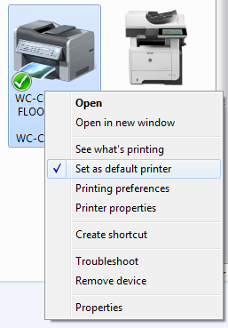
- When printing a document the make sure the wc-cgy-2nd-floor-copier printer is selected to ensure a successful print

