How to create a contact group:
- New Items > More > Contact Group
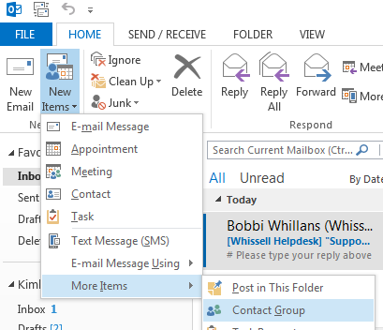

- Add Members > From address book
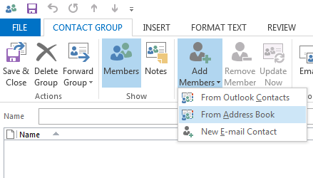

- Ensure you are in the Global Address List.
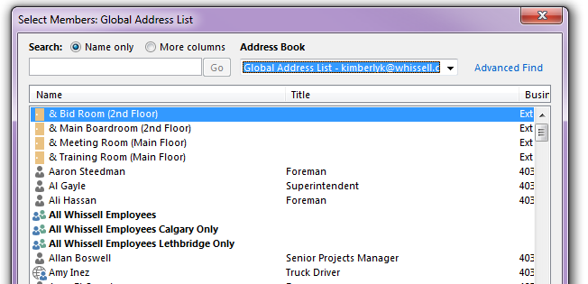

- Double click on users to add their cellphone/email to your group.
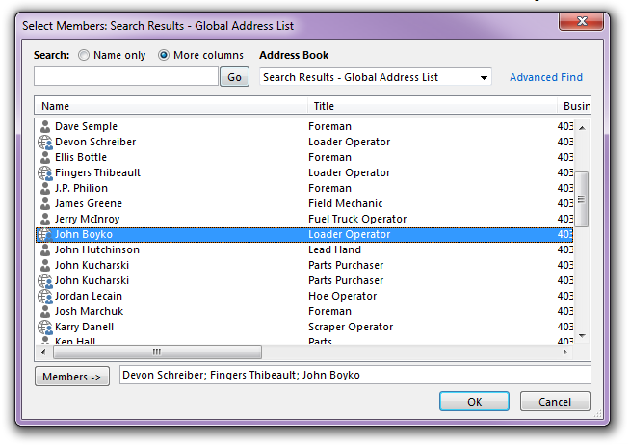

- You can also search by department by clicking on Advanced Find and then typing in the Department you’d like to view.
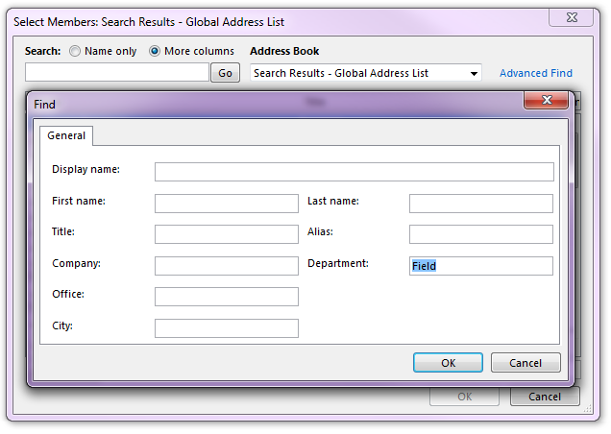

- Here is your new Contact Group. Give the group a name in the Name field. Then Save and close.
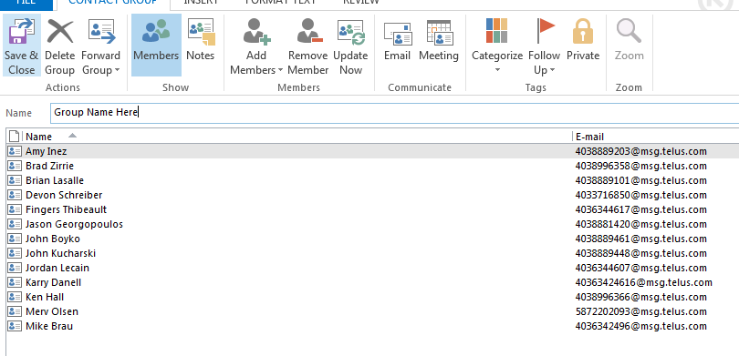

- To send a message to these users: Start a new e-mail, click on To. Then select Contacts from the drop down menu (because this is your contact list not a global list)
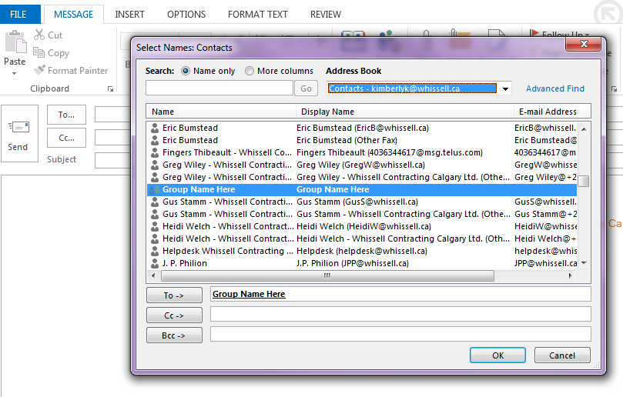

- Scroll through to find the group you’ve created and double click to add them in the To field. Select OK.

