How to connect to Guest Wi-Fi

- Go to Settings > Wi-Fi
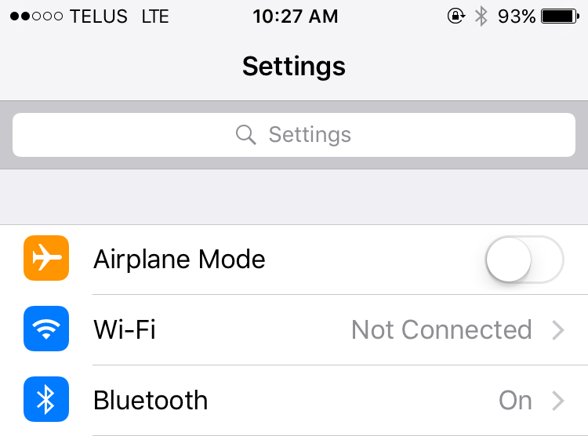

- Turn Wi-Fi on by swiping slider to the right. Then select Whissell-Guest
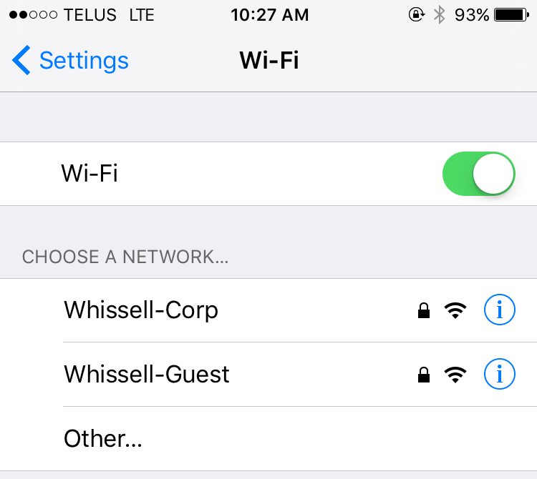

- Enter the password 1234whissell$ and select Join
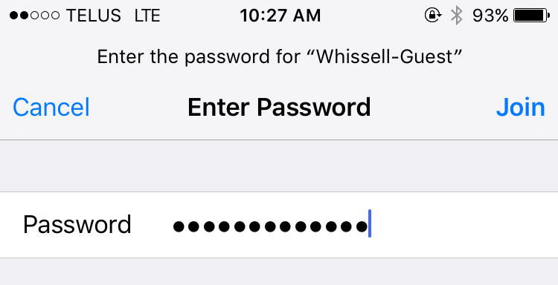

- A network authentication window will pop-up. Select continue to the internet.
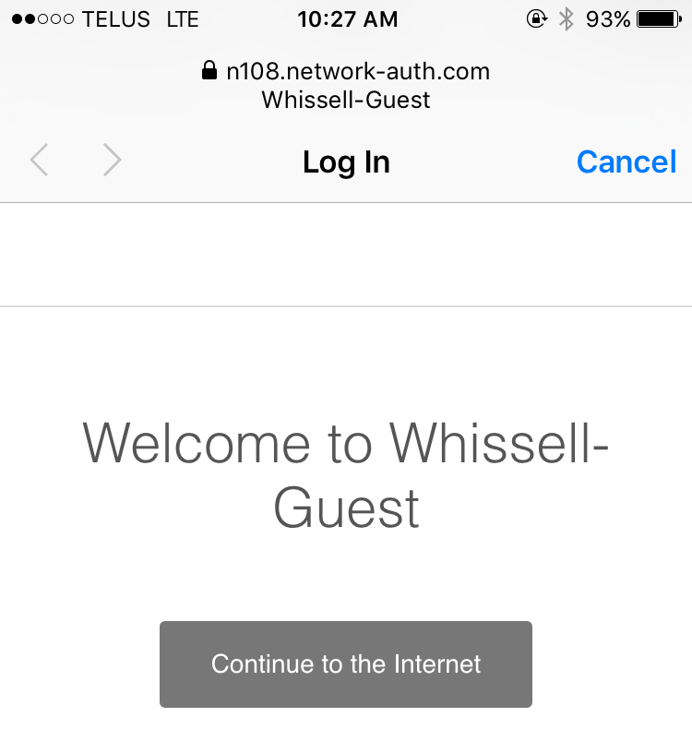

- Select Done
