Example Ticket  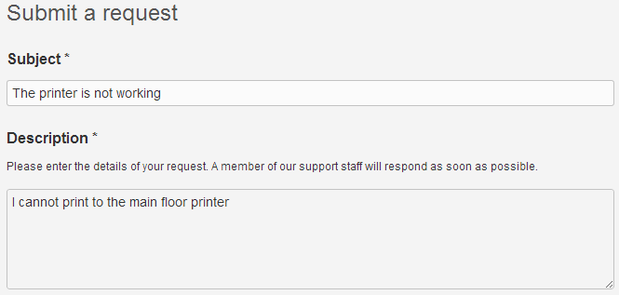  FAQ’s  - Go to http://whissell.zendesk.com/home for common questions and tutorials!
  
  Whissell
    - Help Desk & Ticketing System
  Web: http://helpdesk.whissell.ca
  E-mail: helpdesk@whissell.ca

What Is It?  - Zendesk is a simple to use online ticketing system that will allow the IT department to better help you with your device questions, problems and needs.  - It will allow us to directly connect with you through e-mail to keep you updated on the status of your ticket.  - Zendesk also has the capability of a knowledge base for frequently asked questions or solutions to problems that you may have encountered before but forget how to solve!  How Does It Work?  - A request is submitted into Whissell using e-mail helpdesk@whissell.ca or using the web-interface http://helpdesk.whissell.ca  - The IT team will be notified through e-mail of the new issue and will assign and solve the issue based on severity or importance.  - The ticket will include an integrated discussion (online and through e-mail) for every issue. Employees and technicians can post updates and interact with each other regarding the status of the ticket. |  | Getting Started  There are two options to submit a ticket to Whissell IT – Through e-mail or the web.  __________________________________  - E-mail helpdesk@whissell.ca  - Go to http://helpdesk.whissell.com  - Your account will already be created! Click the login button in the top right corner of the site  - Username: Your Whissell E-mail address (ex. user@whissell.ca)  - Password: _______________________  (You will be prompted to set your password during your first login. This password will never expire so you should write it down in case it is forgotten)  - You can also check off the “Stay logged in” option |  | Creating a Ticket    1. If you’re using the web interface – After logging in - In the top menu of the website under the Whissell logo; click on:  2. The Subject field should give a brief overview of what the issue is.  3. The Description field can be used to add extra details if necessary (This field cannot be left blank). Try to be as specific as possible!  4. (Optional) An attachment may be provided to further explain or show the issue you are having (Such as an error message popup)  - To capture this - click on start > all programs > accessories > snipping tool. Then simply click and drag your cursor over the problem area and save the file  