My Conferences  - To create a conference call click Add Conference  - Fill out the conference scheduler by selecting a password, date and time  - Example:  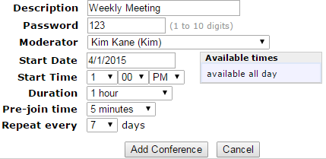  You by default  - After you have submitted the conference settings, note the Conference ID and password to give to others that will be joining the call.  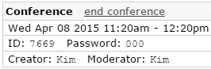  You  You  - To cancel a conference call – click end conference in the Allworx portal.  Joining a conference call |  | My Conferences Continued  - To join a conference call from your Allworx phone:  - dial *408 (a conference ID and pin will be required)  - To allow an external caller to join in the conference:  - Have them call reception or your Allworx phone  - Ensure they have the conference ID and password  - Press the Transfer button to put the caller on hold  - Dial *408  - Hang up or press the XFER soft key. Your phone will then display “Call Transferred”  - The external caller will be prompted to enter in the conference ID and password  Access your voicemail from any phone by dialing 403-570-7176
  Whissell
    - Advanced Allworx Phone Features
  Web: http://192.168.2.50
  E-mail: helpdesk@whissell.ca
  

Accessing Allworx Web Portal  - The Allworx web portal allows you to manage your desk phone’s features such as:  - Viewing the company Allworx directory  - Setting up call forwarding to a cellphone or a different extension  - Creating a conference call  - To access the portal - go to http://192.168.2.50 in your web browser. Bookmark this link for easy access!  - Login with your username and voicemail pin (Username is Case Sensitive!)  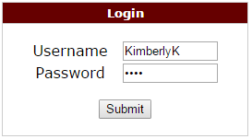  - After logging in you will see this menu:    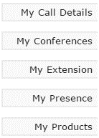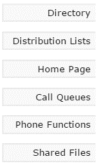  - The rest of this brochure will explain what the key features are and how to use them! |  | My Account  - Password – changes your Allworx portal login password. Pin – changes your voicemail pin  - The default voicemail pin is 1234 – make sure you change this!  Write your password/pin here: _______________  Directory  - List of all the Whissell employee’s that can be dialed by a 4 digit extension number  - Use the search bar to quickly find a person’s extension  - View current presence settings for Whissell employees  My Presence  - Your presence is how you control the status your availability or location.  - You can also setup specific voicemails for different presence options  - The presence options are:  - Note: Changing your presence can also be done by clicking the Presence soft key on your phone |  | My Extension  - Allows you to setup call forwarding for a specific presence setting while you’re out of the office.  - Click on Modify corresponding to the presence option you’d like to change.  - Select the Dial number option. You can forward calls to your cellphone, or another Whissell extension.  Extension: 4 digits (ex: 2200 = reception)  - Ext. numbers can be found in the directory  Cell format: 9 (XXX) XXX-XXX (including the brackets and dashes)  - Click Update Call Route when you’re done. Call your phone from another line to do a test.  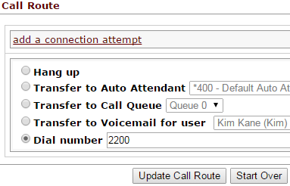  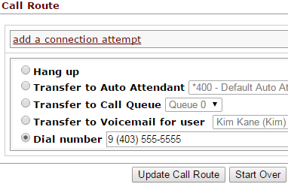
  - In Office  - At a Meeting  - On Vacation  - On Business Trip | - At Home  - Away  - Busy

