Welcome to your iPad!

The OtterBox Case
- Multi-layer iPad Air cover designed to protect against potential damage from drops, bumps, dust and scratches
- Versatile shield stand provides additional protection during transport and convenient typing and viewing angles
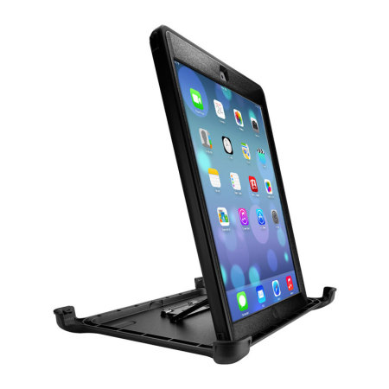
Vertical Stand
Horizontal Stand

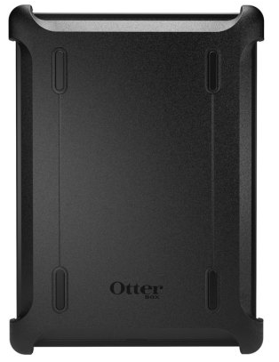
Screen Cover

