How to connect to GlobalProtect and Build 2 Win (B2W)
Note: You must be disconnected from Wi-Fi to access GlobalProtect & B2W

- Open the GlobalProtect app – This app allows access to the Whissell network / B2W
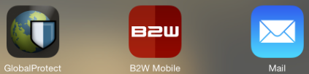

- On the Home tab – Click Portal
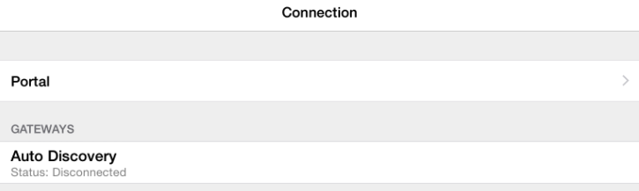


- Select Connect – if your username and password is not auto-saved, enter it here.

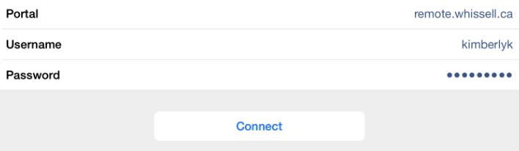

- You are now connected!
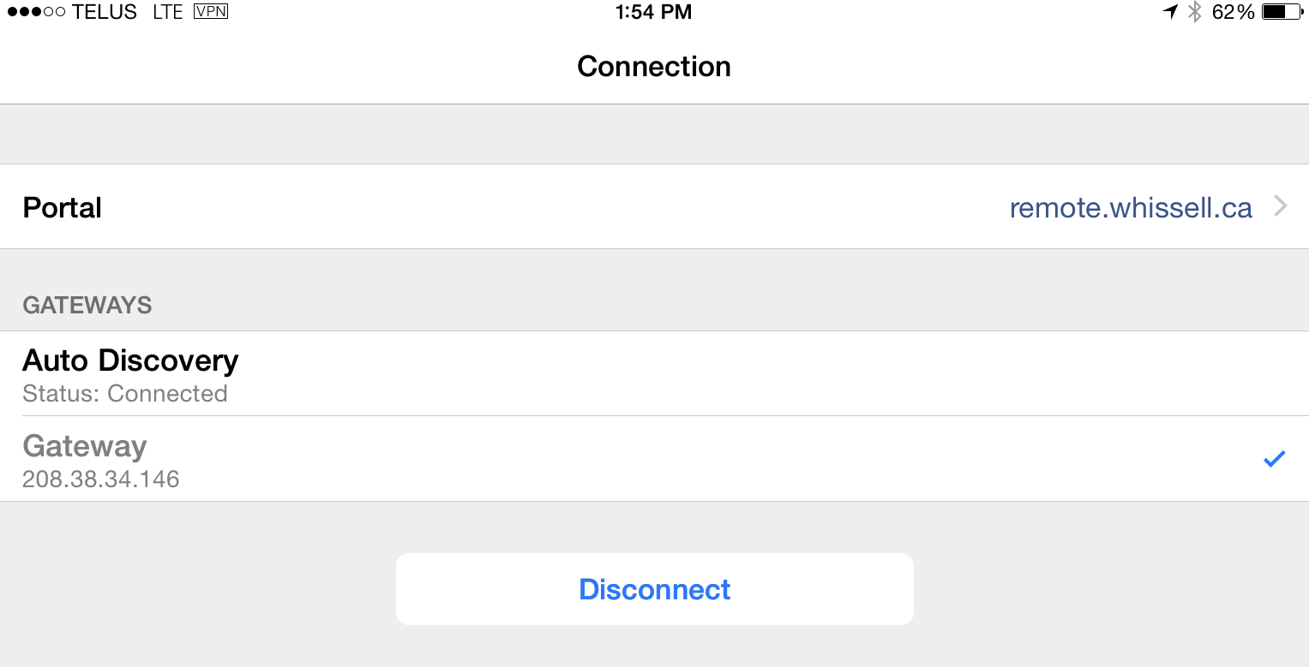

- Open the B2W Mobile app

- Select your username from the list and enter the unique pin given to you. Then select sign in.

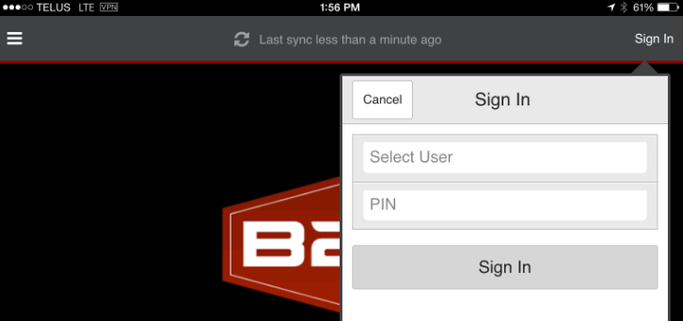

- Click on the “Last sync” text to bring up the Sync Now option – B2W should be synced whenever you’re doing time to get updates

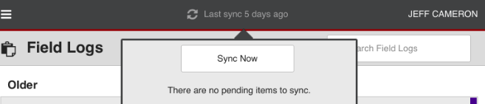
Don’t forget to disconnect from GlobalProtect when you’re done!

B2W Tutorial:
- Please review the detailed tutorial for the B2W app under Settings > Help. Slide your finger across the screen to view the other pages.
