How to connect to home Wi-Fi
- Open Settings
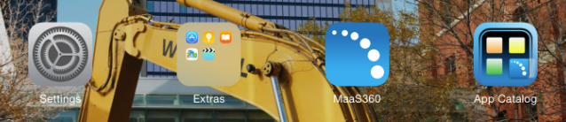

- Choose your Wi-Fi network
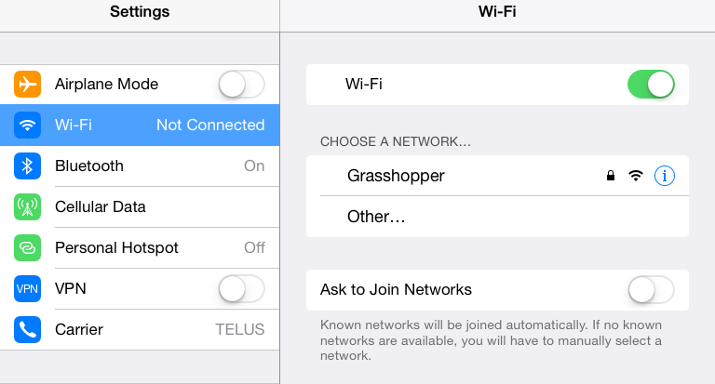

- Enter in the W-Fi network password then select Join
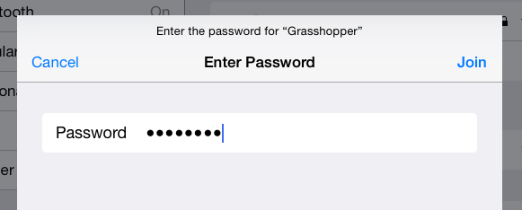

- Once you see a check beside the Wi-Fi connection and a wireless icon on the top left of your screen you have successfully connected to Wi-Fi
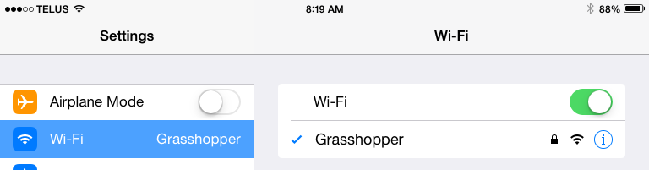

- Wi-Fi must be turned off to connect back to the GlobalProtect VPN / B2W

