GlobalProtect Remote Connection to Whissell

- Connect to the internet via aircard
- Click the arrow on your taskbar then right click on the GlobalProtect 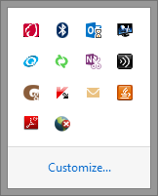icon. Click Open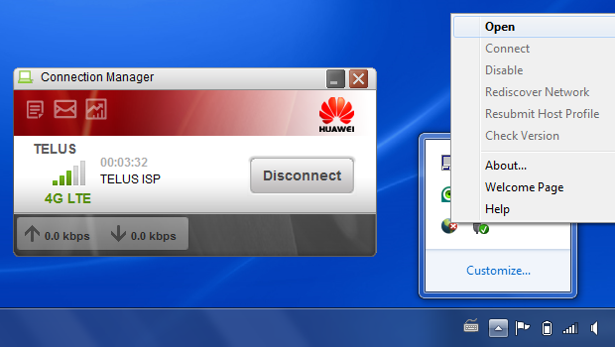

- Login with your Username:
Login with your Password:
Remember Me – to save your credentials
Portal: remote.whissell.ca
Apply
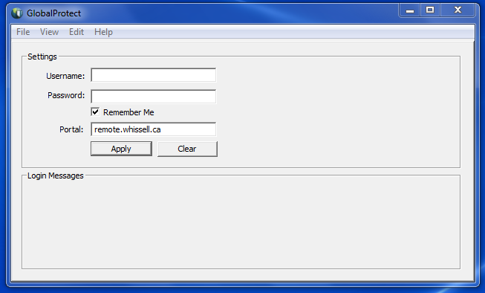

- Continue
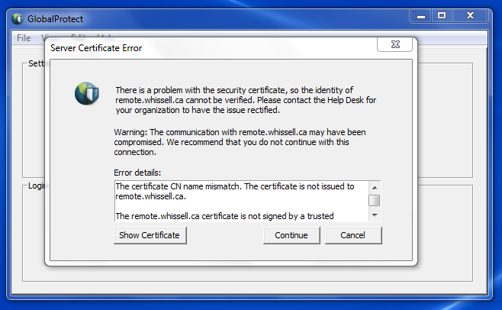

- Notice GlobalProtect is Connecting
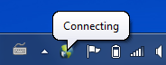

- Disconnecting - Click the arrow on your taskbar then right click on the GlobalProtect icon. Disconnect
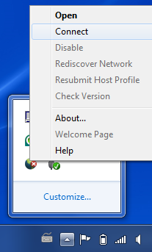
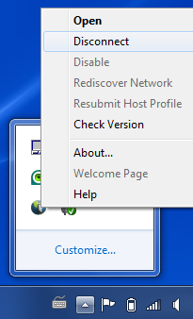
From now on you can just click Connect!

