How to get your TeamViewer ID
- Look in the bottom right of your taskbar for an icon that looks like 
-You may have to click the arrow on the taskbar to see this icon.
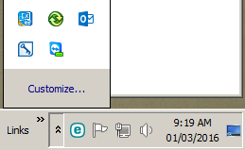

- Once you click the team viewer icon you will see that an ID number appears. This is the number IT requires in order to assist you. 