How to take a picture

- Here is the lens of your camera

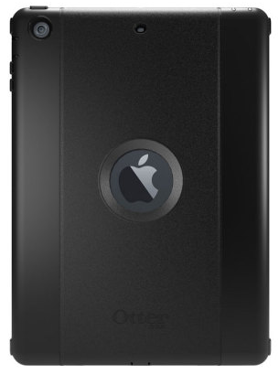

- Open the Camera application

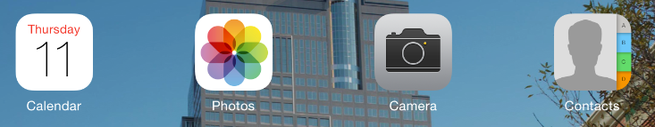

- Press the white button to take a picture



- To view your pictures open the Photos app

- Your photos will be organized by Date and Location

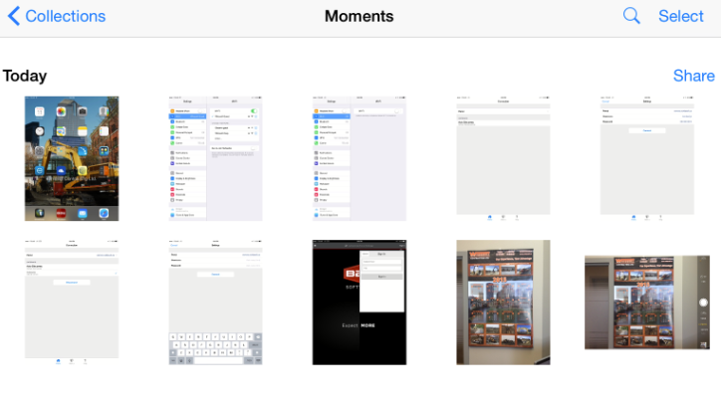

To upload photos see document:
“iPad Users – Transferring pictures from the iPad to the Cloud”

