Troubleshooting
- Ensure you have good signal strength (top left corner). If you have low bars, the area you’re in could be affecting iPad performance.
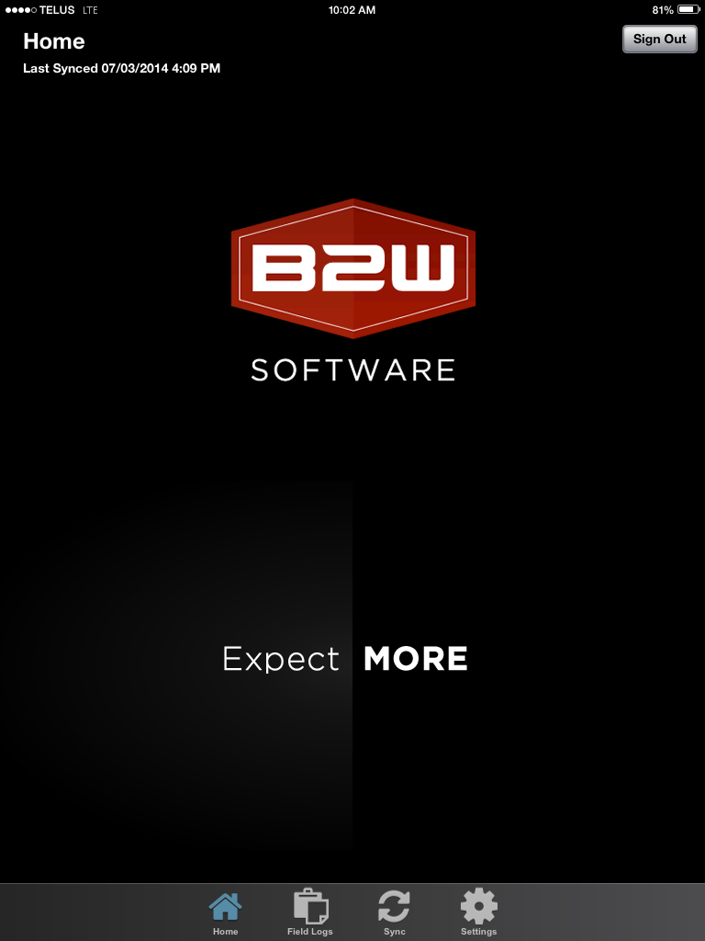

- If you have an app that has stopped responding properly, and will not close by the normal method of pressing the home button, here’s how to force it to close down: Double-press the home button to bring up the Multitasking Bar and then tap and drag the window you’d like closed upward.

- Turn off the iPad by holding down the power button for 5 seconds. Then slide your finger across the screen’s power off button. Turn the iPad back on.
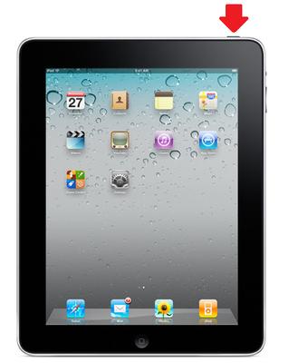

- If you are still having issues: Do a “Hard Reset” by holding down the power and home buttons down at the same time for 30 seconds. Turn the iPad back on.
helpdesk@whissell.ca | 403.570.2169

