GlobalProtect Remote Connection to Whissell

- Connect to the internet via aircard
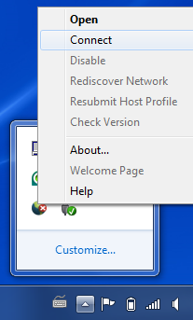
- Click the hidden icon button on your taskbar then right click on the GlobalProtect 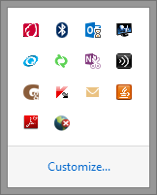icon. Click Connect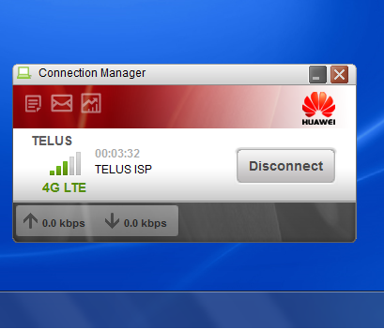

- Notice GlobalProtect is Connecting
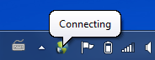

- To disconnect - click the hidden icons button on your taskbar then right click on the GlobalProtect icon. Disconnect
