How to Access Documents from MaaS360

- From the desktop (Press Center Button to go there) look for an Icon that says “MaaS360” it should look like this:
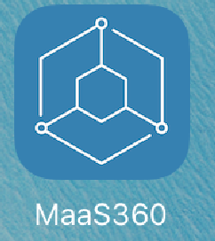

- Click on this icon and you will be directed to a page that looks like this. Click on “Docs”.
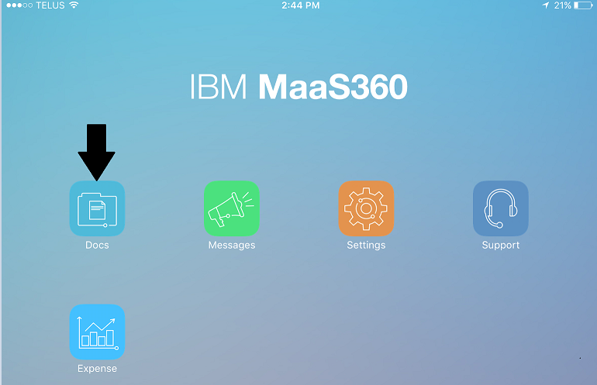

- On the following window click on “Corporate Distributed”.

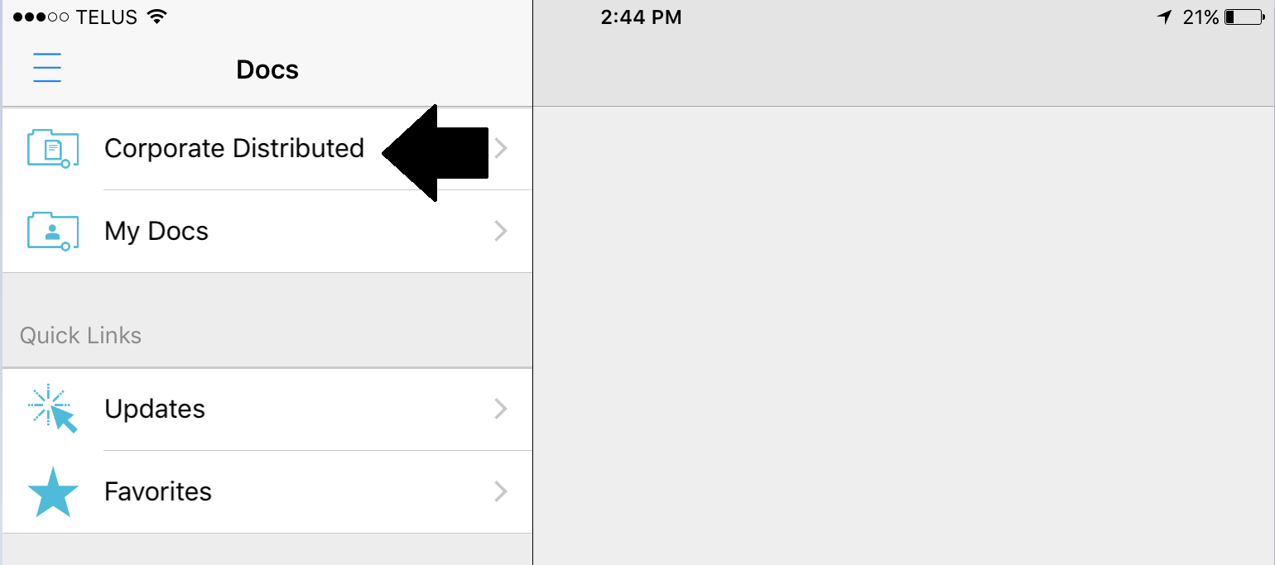

- All documents that have been distributed via MaaS360 will be displayed here.
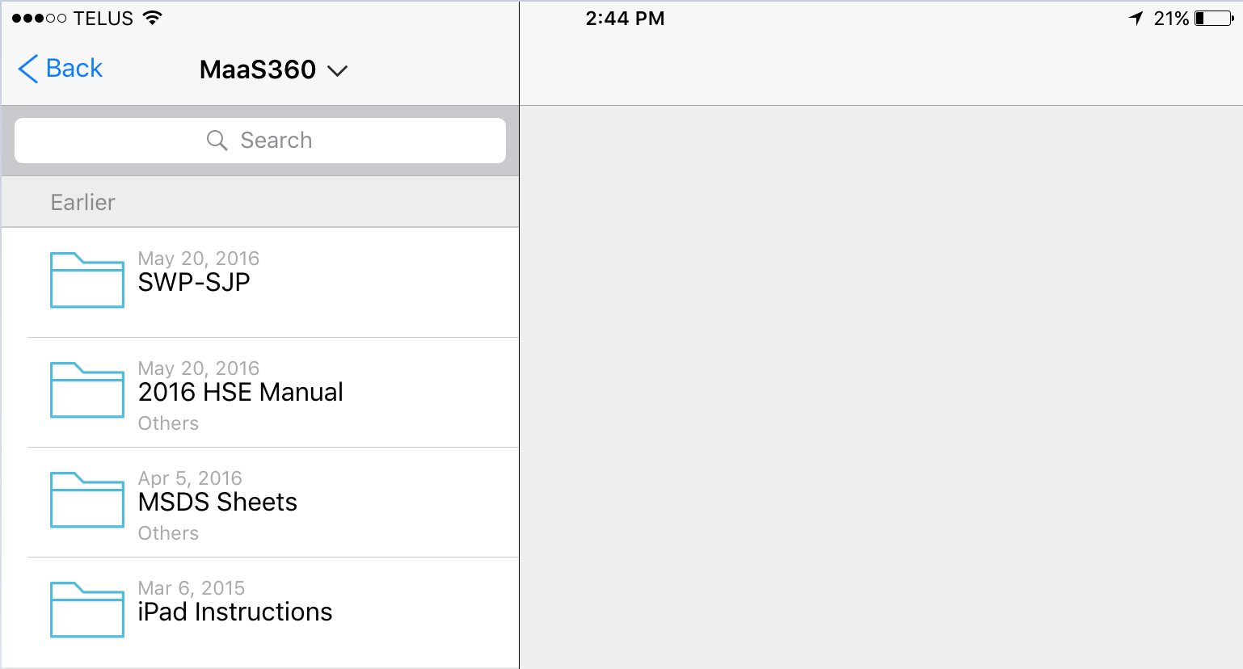
- Click on the folder for the documents you are looking for and then click on the applicable document and it will be displayed on the right.
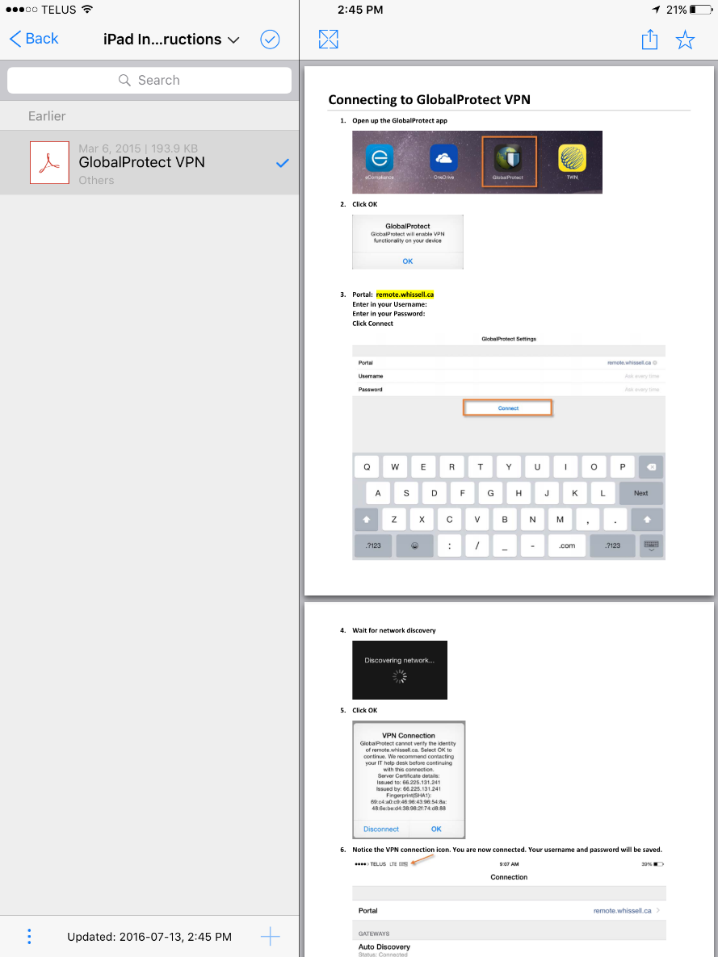
If you have any questions or issues please submit a ticket via our Helpdesk.
http://whissell.zendesk.com

