Operating Standards and Procedures

Document IT-PRO-EM-001-16
Revision 1.0

WHISSELL CONTRACTING E-MAIL SIGNATURE STANDARD

0 | 06/13/16 | Issued for Review | CH
1 | 06/14/16 | Issued for Distribution | CH
Rev | Date | Description | Prepared  By | Checked  By | Approved  By | Description  (Changes)

Updating your Email Signature

- First you need to open up Outlook 2010/2013. Look for an icon that looks like:

 Or 
(2010) (2013)

- Next you need to open a new email to access the Signature portion of Outlook. Click the “New email” button in the top left.

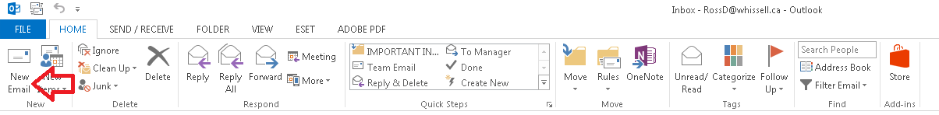

- Once you have a new email open you can click the “Signature” button on the ribbon bar and select “Signatures…”

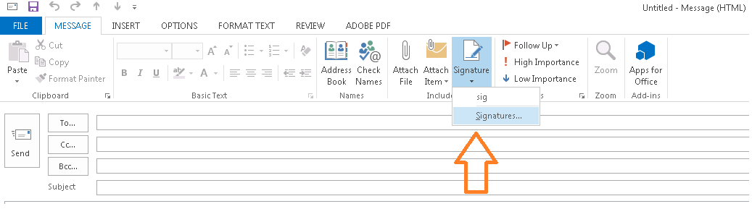

- In the signature menu you can now copy (Ctrl + C) & paste (Ctrl + V) the following signature into the box. Also found in the following location on the corporate drive: N:\Corporate\Policy\Human Resources

Name, credential if applicable
Position | WHISSELL Contracting Ltd.
Main: (XXX) XXX-XXXX | D: (XXX) XXX-XXXX | C: (XXX) XXX-XXXX | E: name@whissell.ca
Whissell S.P.I.R.I.T. | Safety | People | Integrity | Respect | Innovation | Teamwork

- Ensure all the information in the applicable boxes are correct and that the “New Messages & Replies/Forwards” boxes are selected to pick your new signature/existing signature.

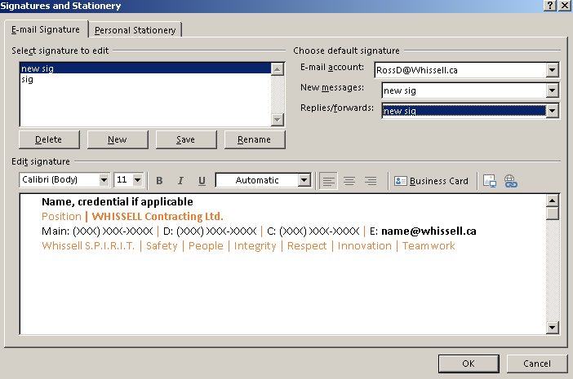

- Click OK and then proceed to create a new email as directed above and you will see the new signature you have created is now default on all emails.
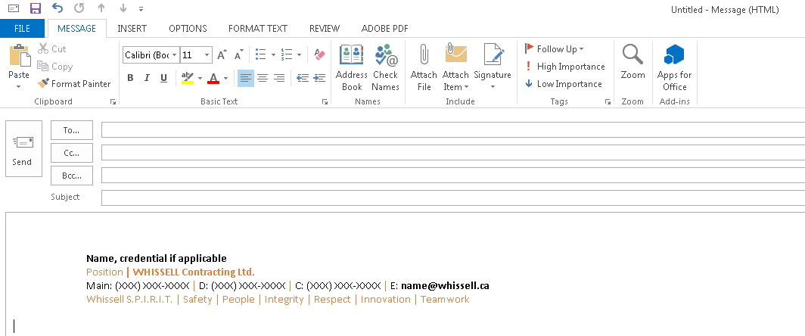

Please be aware these signatures are only applied on your computer. It is not possible to have this sync to your Ipads or Phones.

If you have any questions or comments please let us know via our Help Desk portal (http://whissell.zendesk.com).

Thanks, Ross Doeleman

