How to Install B2W Estimate

*REBOOT YOUR SYSTEM BEFORE DOING THIS INSTALL*

- Run the install file from the following directory:

- Click “Setup” in the window that appears.
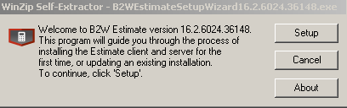
- Click “Next” in the window that follows.
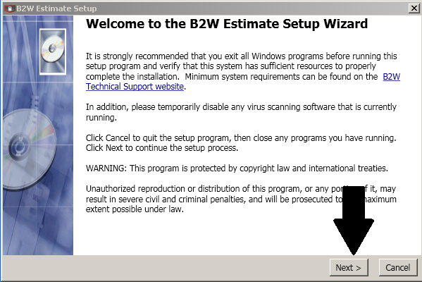
- Scroll down to the bottom of this window and then click “Next”. 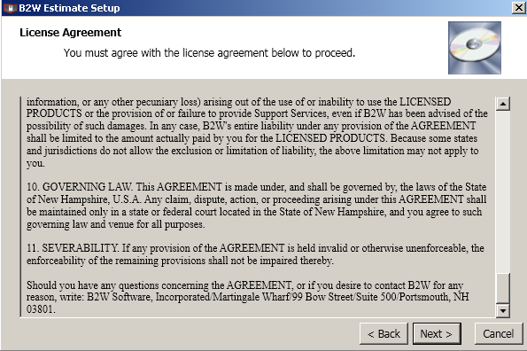

- Click “Next” again on the following windows.

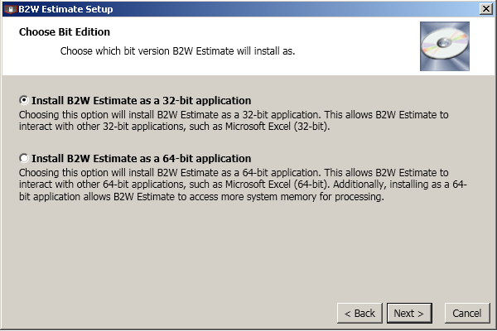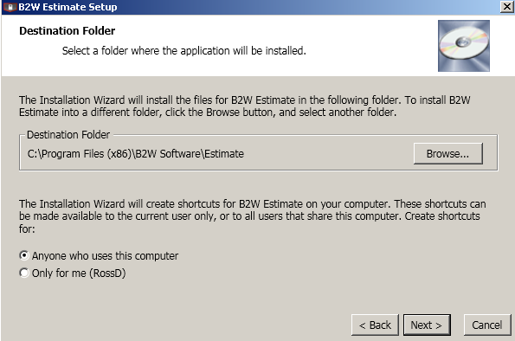

- Ensure that “Network Client” is the option selected and then click “Next” once again. 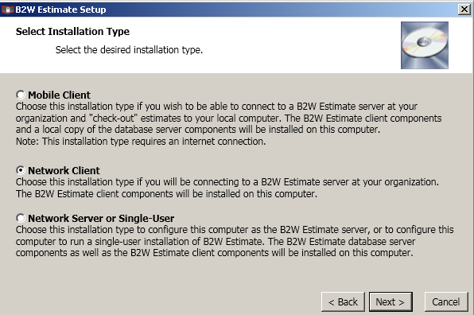

- Click “Next” on the window asking about the default database. 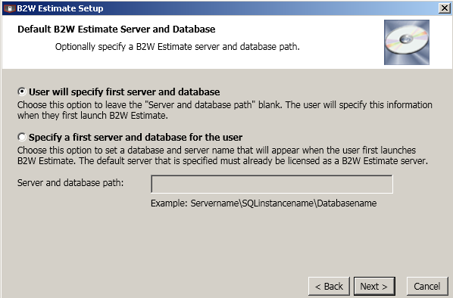
- Again click “Next” to proceed.

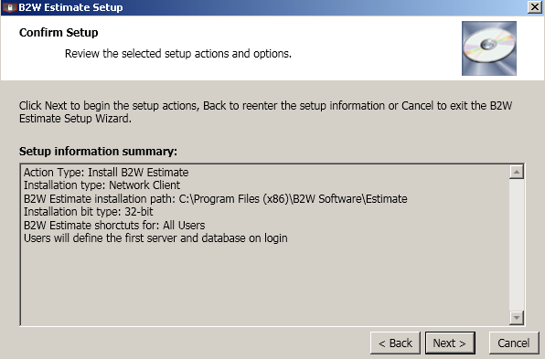

- Estimate will now install.
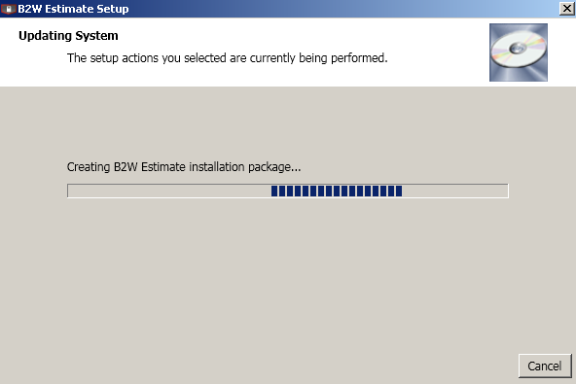
- Click Finish and then launch estimate via your start menu.
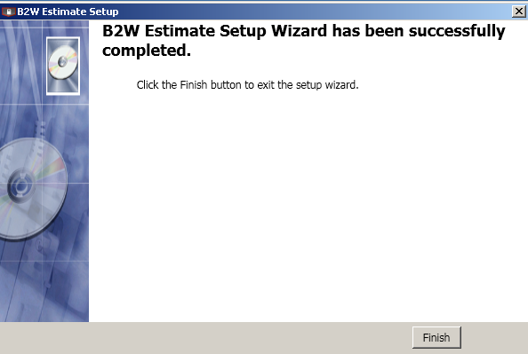
- Now you can run Estimate from your start menu.
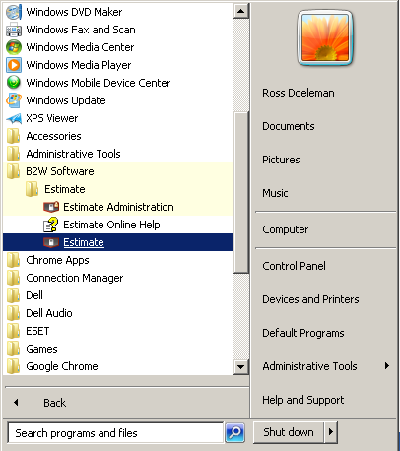

- You may receive an error when starting Estimate that looks like this: (or variation of)
Click on the OK box.
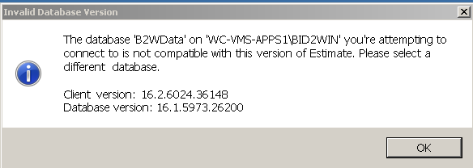

- It will then prompt you to enter in your Username, Password & Database.

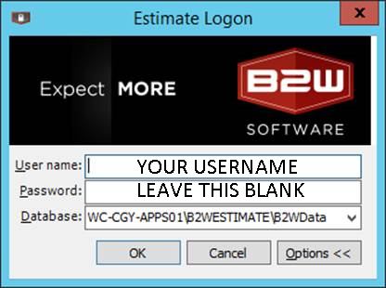
Username: This will be your username (Example: Rossd)
Password: BLANK
Database: WC-CGY-APPS01\B2WESTIMATE\B2WData

- Once you have typed in the above information click on the OK box and you will now be able to use Estimate.
If you have any questions or concerns please submit a ticket via our Help Desk.
http://whissell.zendesk.com

