- Delete all old shortcuts in the following 2 locations as they will no longer work once the old B2W server is decommissioned.
  - Open Internet Explorer.
  - Left Screen: Remove the icon from the toolbar, Right Click the B2W Icon then choose “Delete”.
  - Right Screen: Left Click to open the “Favourites” menu. You will see the B2W Track icon. Right click on B2W icon and select “Delete”.

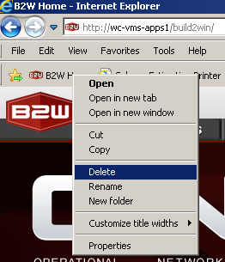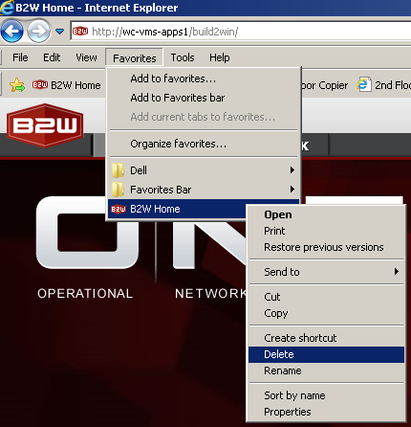

- Any other icons that point to B2W Track will also need to be removed.
  - To do this Right Click on the B2W icon and click on Delete and then click yes.
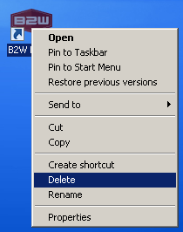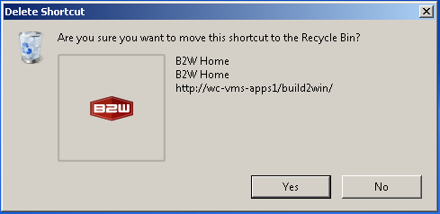

- Adding Updated B2W Favourite Link:
  - Open Internet Explorer 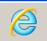 and in the Webpage Address bar at the top of the browser type the following address:
http://wc-cgy-apps01/b2w
- After the address has been typed, press Enter on your Keyboard. You will be directed to the B2W website.
  - Creating the “Favourites” shortcut icon:
  - Left Click on “Favorites” and then Left Click “Add to Favorites”.
  - The “Add a Favourite” menu will open. Left Click the “Add” button.

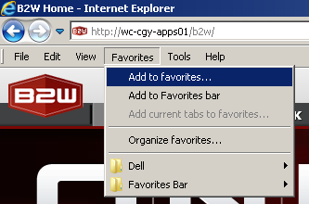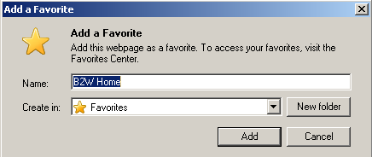
- To add the B2W icon to the Favourites Toolbar,
  - Creating the “Favourites” shortcut icon:
  - Left Click on “Favourites” and then Left Click “Add to Favorites Bar”.

- Creating Desktop Icon.
  - Open Internet Explorer
  - Right Click on the B2W Home Icon in your Favorites and Left Click “Send to” and Left Click “Desktop”.
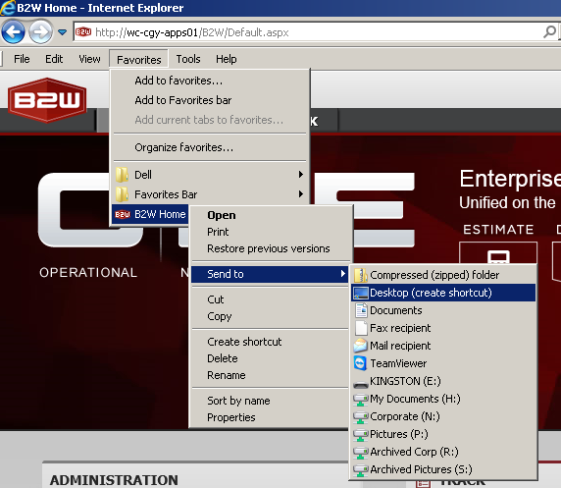

  - 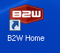 Icon will appear on your Desktop.

If you have any issues please submit a ticket via the Whissell IT Helpdesk: http://whissell.zendesk.com

