How to uninstall and reinstall B2W Mobile App
*YOU WILL NOT BE ABLE TO ENTER TIME UNTIL THE BELOW STEPS ARE COMPLETED*
*YOU MUST BE CONNECTED TO VPN/GLOBAL PROTECT TO PROCEED.*

- Click the center button on the iPad (the circle) and go to the home screen. Hold your finger down on the B2W Mobile app for 2-5 seconds until the icons start to wiggle/move and then click the X.

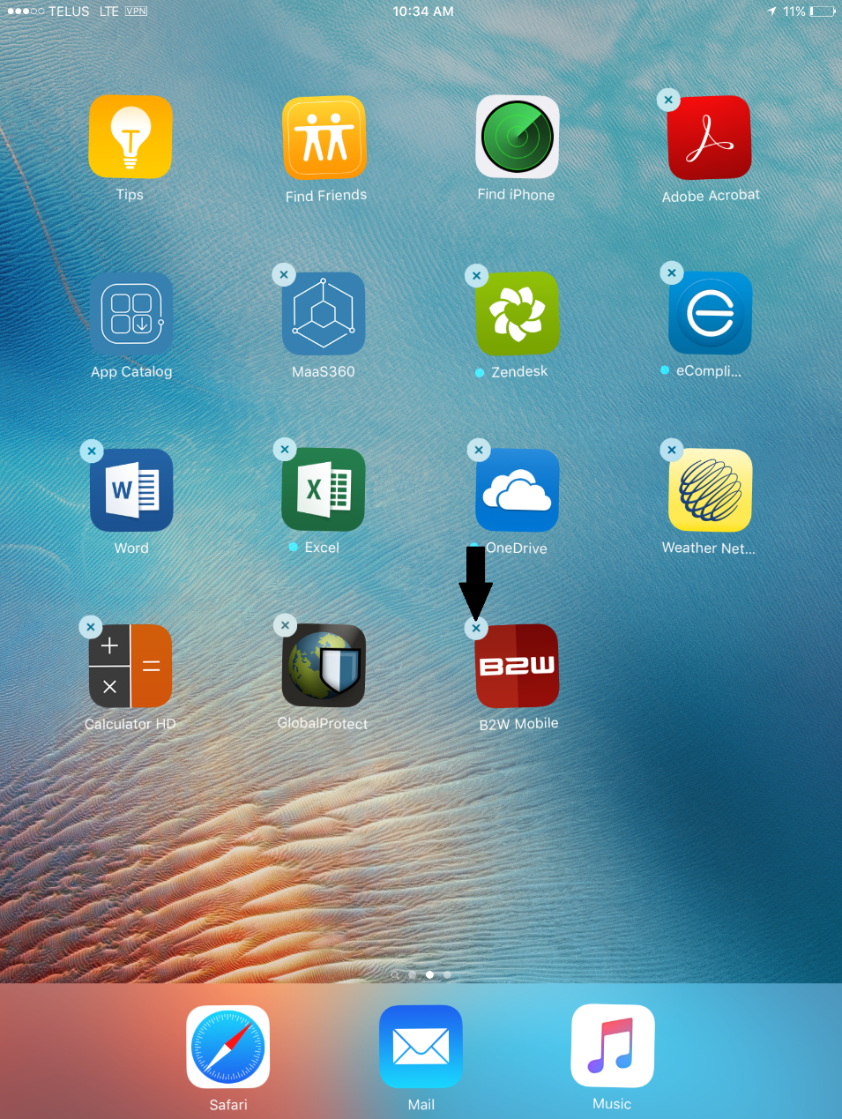
- You will now see a pop up asking if you want to Delete or Cancel. Click on “DELETE” 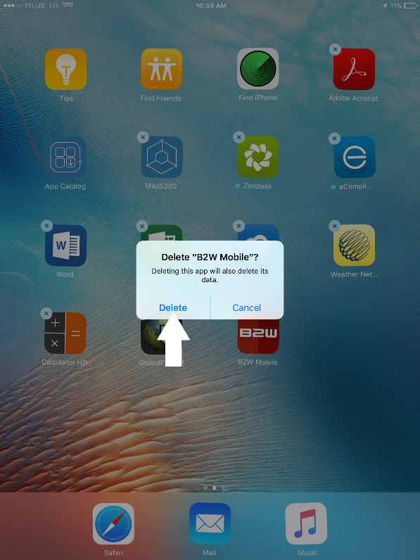

- B2W Mobile is now removed from the Ipad as the Icon is no longer there. 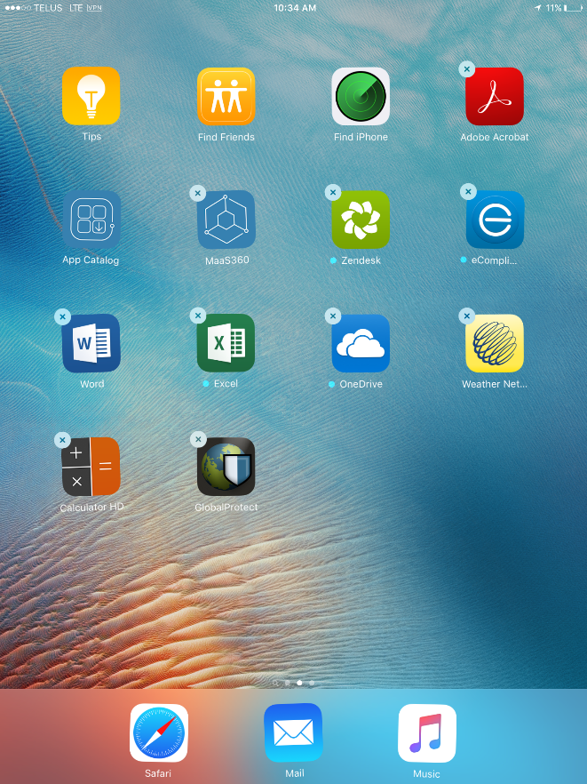

- Click on the Icon that says “App Catalog” the icon looks like this:
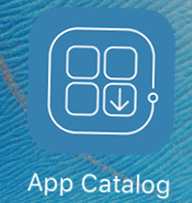

- Once in the App Catalog click the “INSTALLED” button next to the B2W Mobile App.
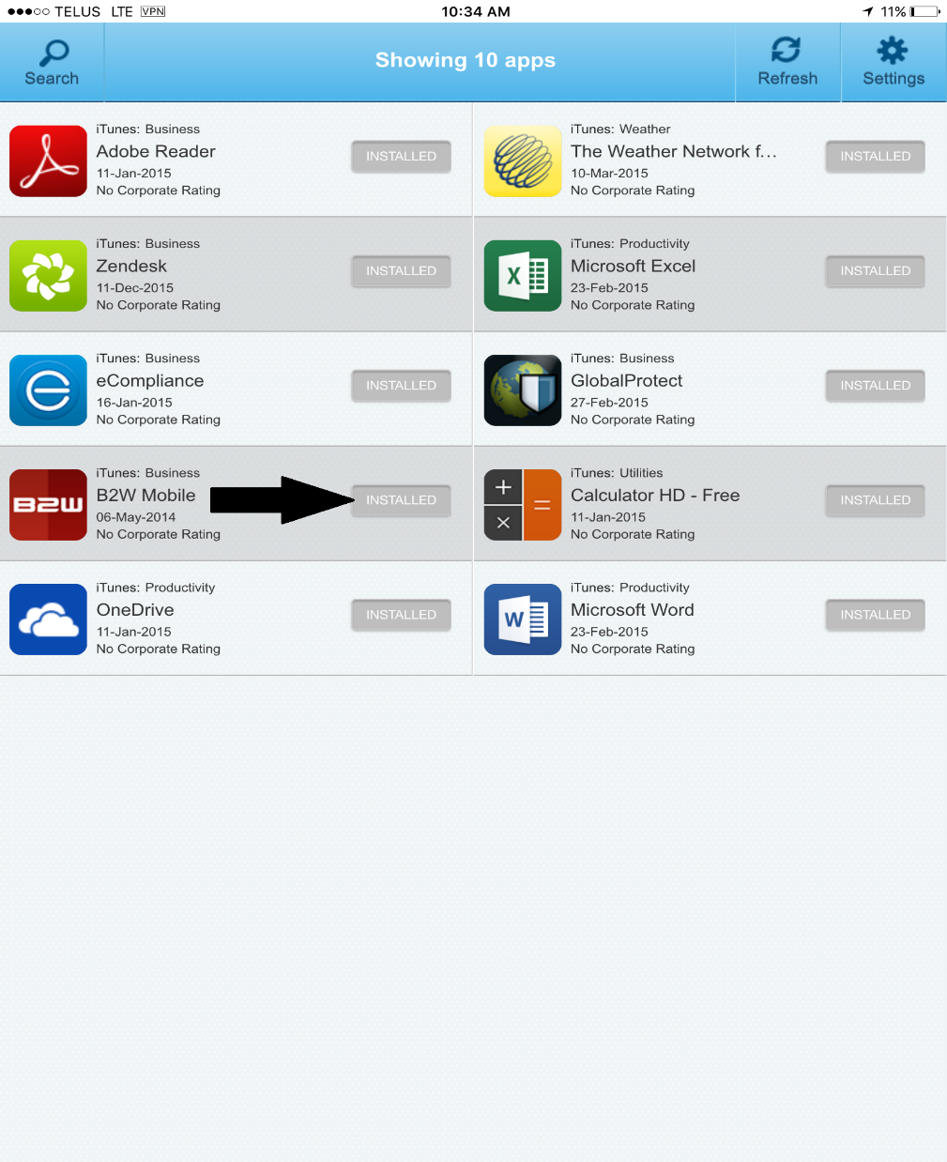
- It will now prompt you to either continue or Cancel. Click CONTINUE. 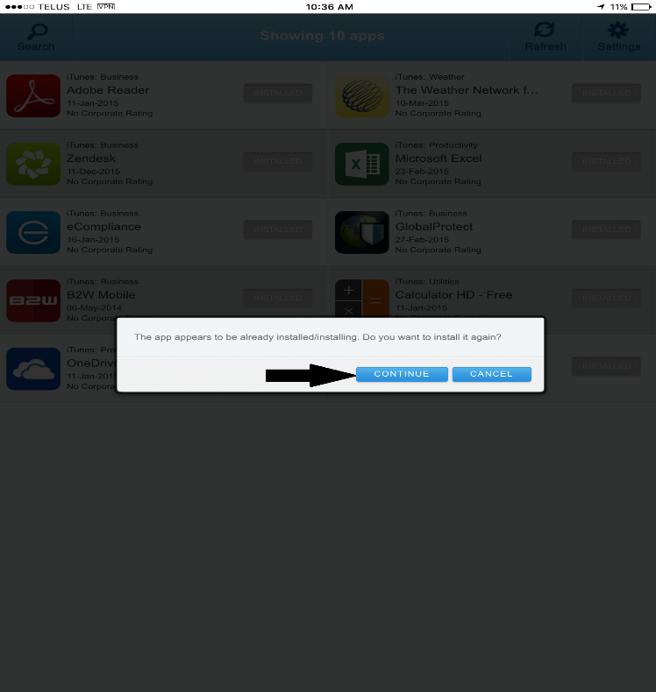
- The app will now install in the background. Click OK and then press the Center Key once again to get to the home screen.
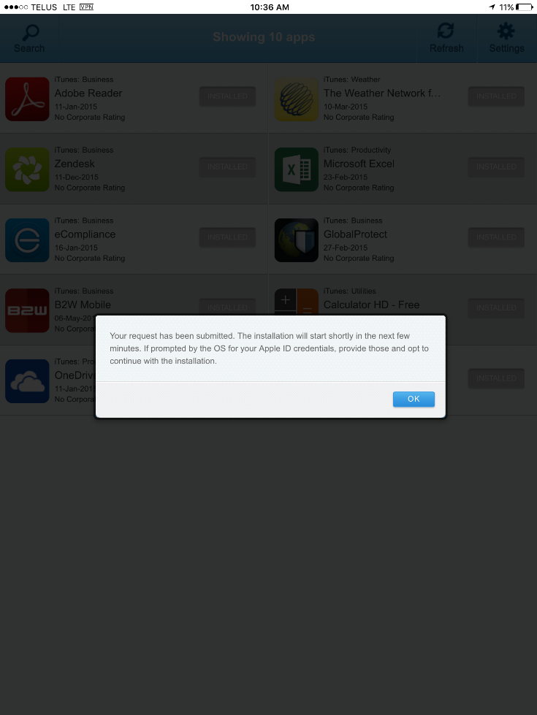
PLEASE NOTE: IT MAY TAKE UP TO 15-30 MINUTES FOR THE APP TO APPEAR & INSTALL.

- B2W will now install the app. You can tell once it’s completed as the icon will no longer be blacked out.
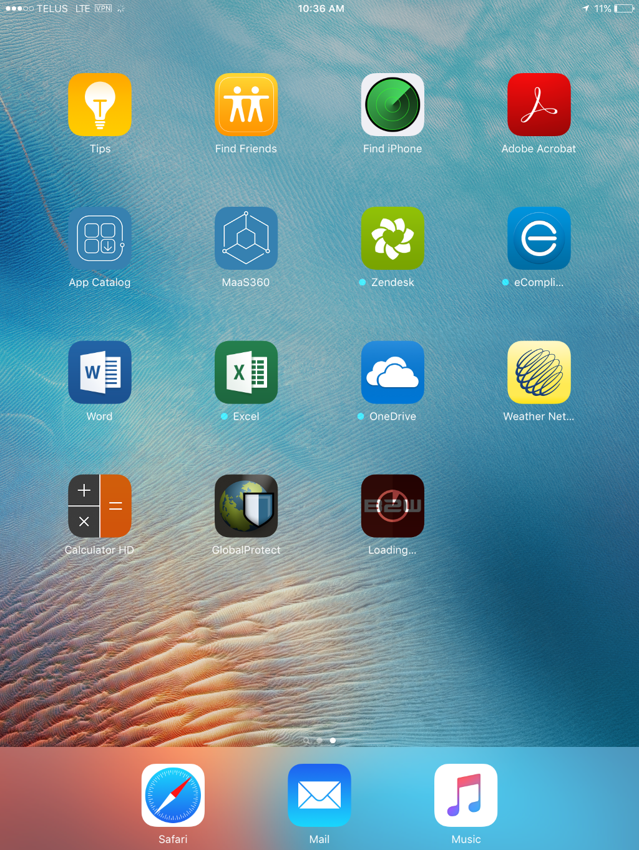

- Find your Ipad Name. This is labeled on the back of the Ipad. It can also be found by going to Settings > General > About

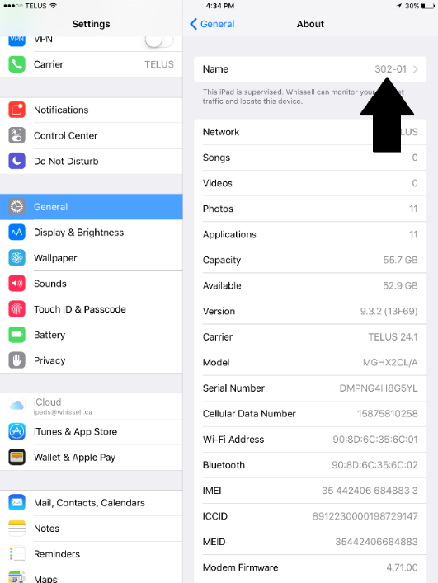

- Click on the B2W Mobile App and it will now prompt you for the following information:
Name:
Server URL: http://wc-cgy-apps01/b2w
Password: 4321

*IF YOU ENTER AN INCORRECT IPAD NAME IT WILL BE REMOVED FROM THE SERVER AND YOU MUST SUBMIT A TICKET VIA OUR HELPDESK http://whissell.zendesk.com*

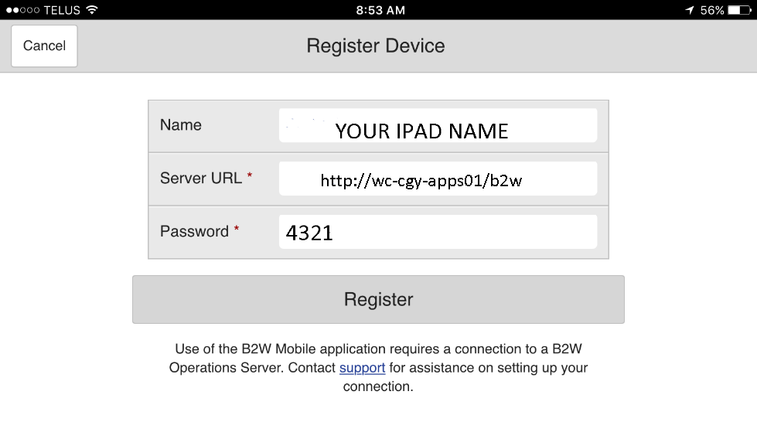
- Now that you have registered the device on the B2W server you can now click the Sync Icon in the center of your screen. 
- In the following window that appears click Sync Now and you will now be able to login to B2W.
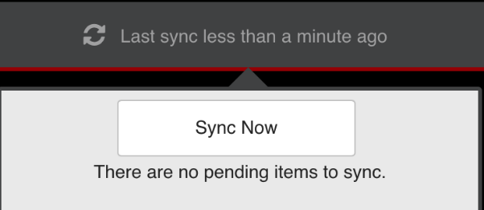
If you have any issues or questions please submit a ticket via our help desk (whissell.zendesk.com)

