How to Remove Credentials from Vault in Windows 7

- Click on the start menu in the bottom left of your screen. 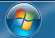
- In the box at the bottom type in “Credential” and then click on the option that says “Manage Windows Credentials”.
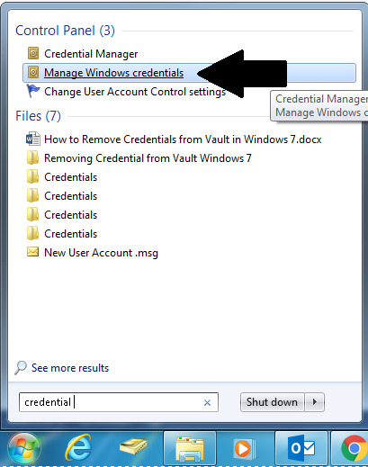
- In the window that appears click on the down arrow next to the credentials you would like to delete. (The one with your email address). 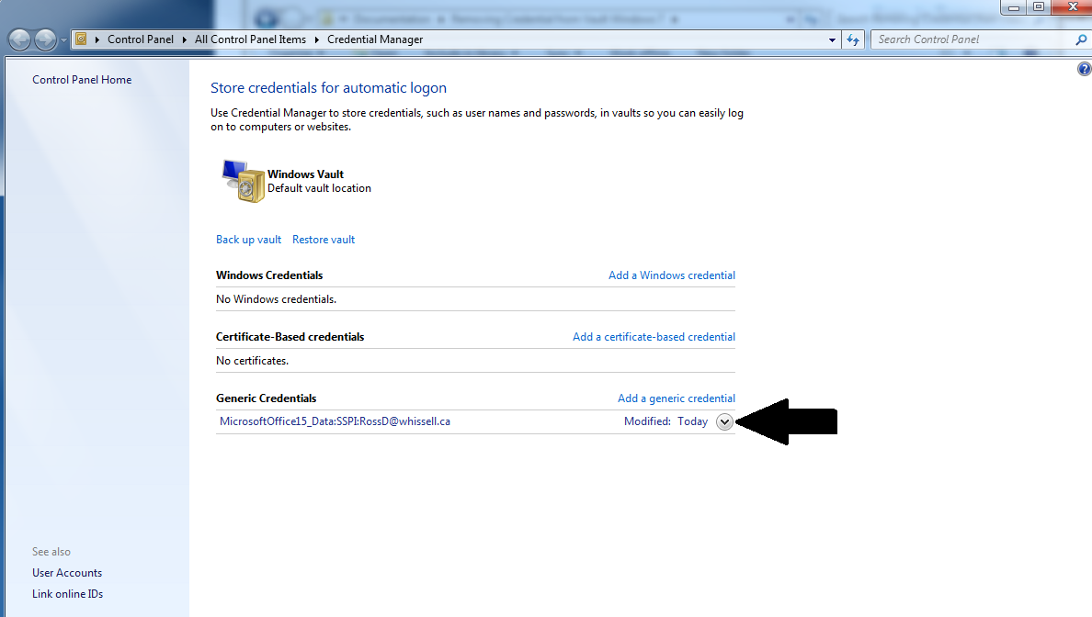

- Click the “Remove from Vault” option. 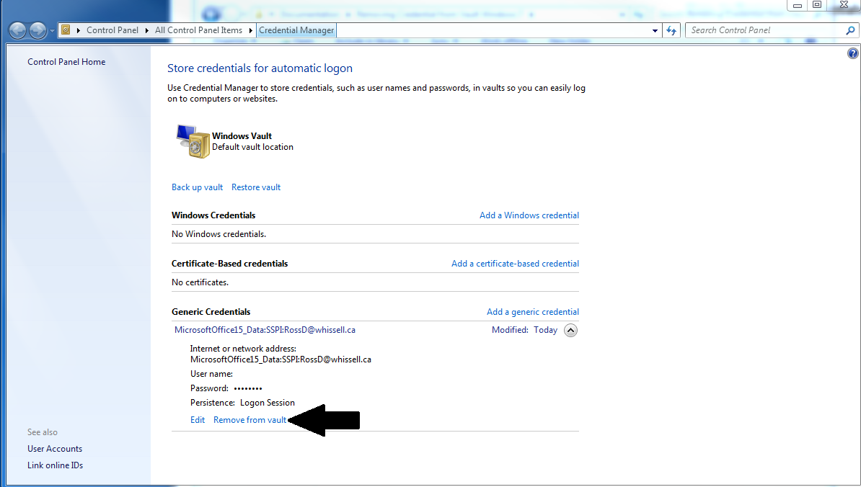

- You will be prompted to confirm you want to delete this. Click on “Yes”.
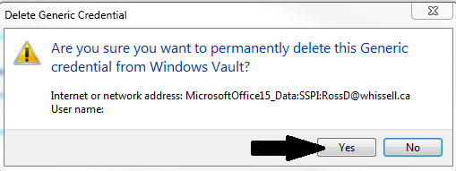
- You will now see they are removed from the vault. 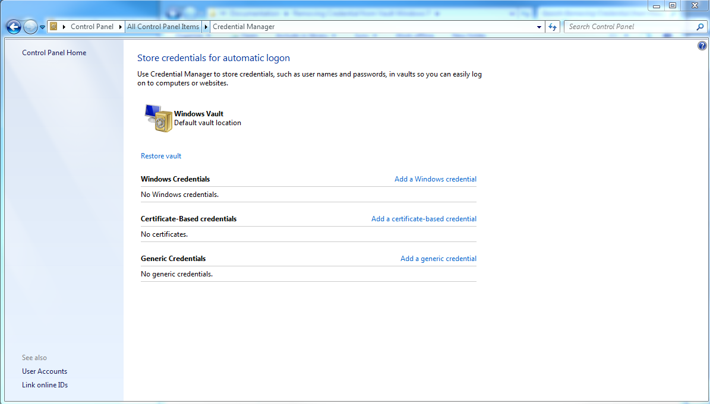
- Once removed from the Vault you can open your email client (Outlook 2013 or 2010).
 Or 
(2010) (2013)
- Once outlook has opened it will now prompt you for your email and password. Type these into the box and click on the “Remember my credentials” option, then click OK.
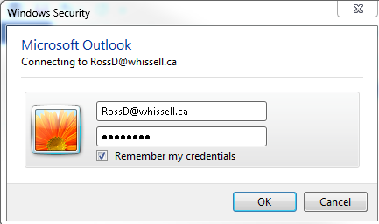
- Outlook will now verify those credentials are correct as you can see in the bottom bar as pictured below.

- Once your credentials have been verified it will say “Connected to: Microsoft Exchange” and you will be able to access your emails.

If you have any questions or issues please submit a ticket via our Help Desk portal.
http://whissell.zendesk.com

