How to Uninstall B2W Estimate

- Click on the start menu in the bottom left of your screen. 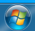

- Click on “Control Panel” in the menu that appears.
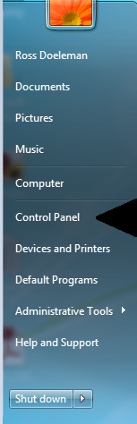
- Click on “Uninstall a Program” or “Programs and Features” depending on your view settings. 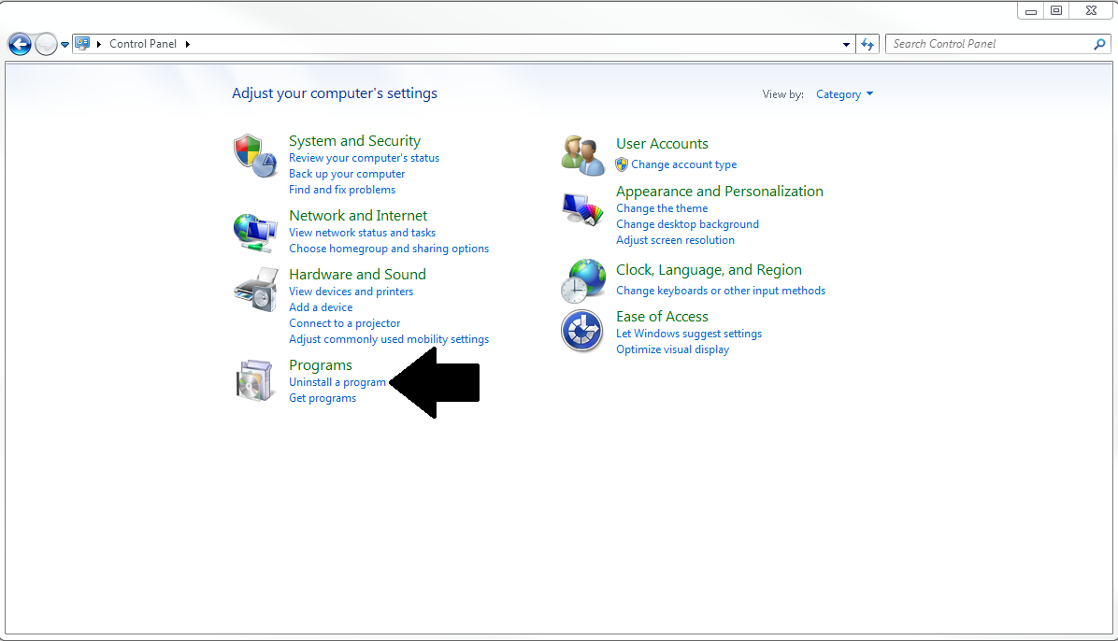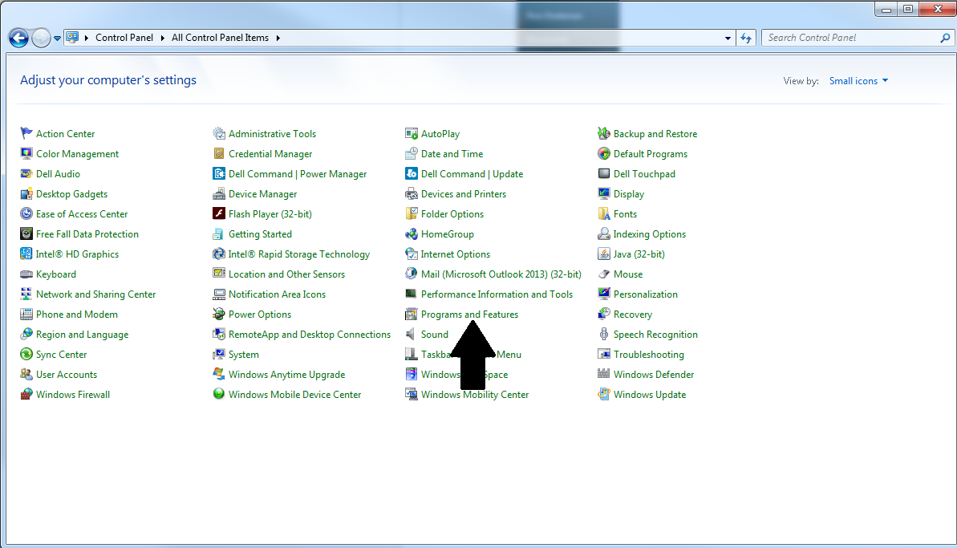
- Find B2W Estimate from the list that appears. It should be near the top as it is alphabetical by default.
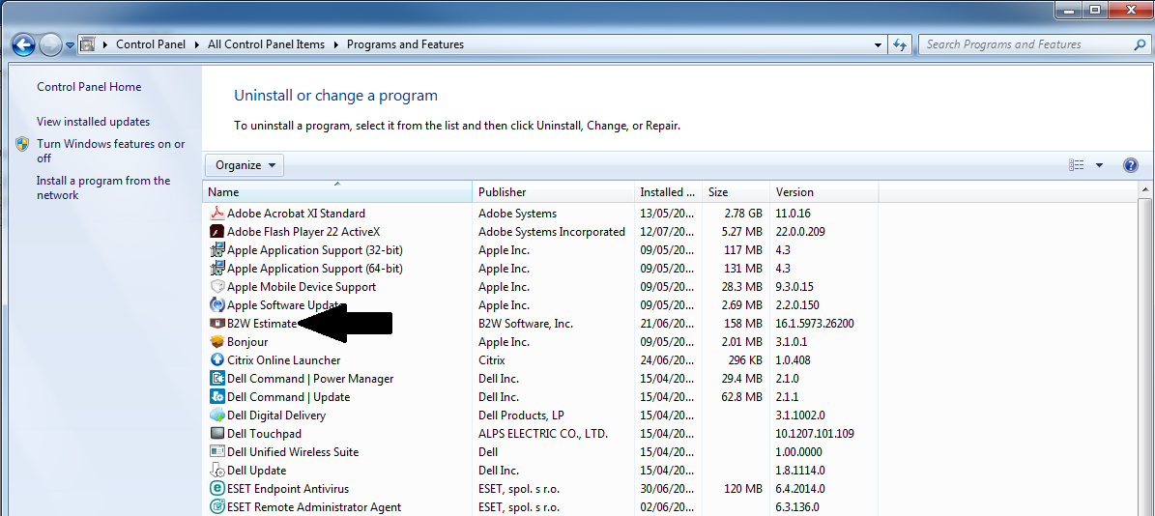
- Once clicked on B2W click the Uninstall button and then click yes on the prompt that follows. 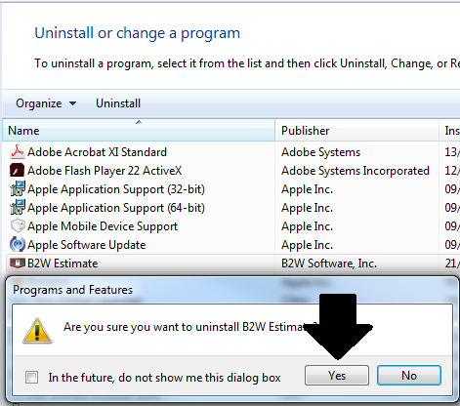
- Once this has been completed you are now able to proceed with the guide of installing the new version of B2W Estimate.

